Athens, 28 June 2023
REQUEST FOR OFFERS 3-2023/MIO-ECSDE

for services for the

For the Implementation of a Tailor-Made Activity to support the Waste Management Plan of the Deir Qanoon El Naher Municipality (Lebanon)

MIO-ECSDE is herewith requesting your best offer for the provision of services for the Implementation of a Tailor-Made Activity to support the Waste Management Plan of the Deir Qanoon El Naher Municipality (Lebanon) within the framework of the MED4WASTE project (https://www.enicbcmed.eu/projects/med4waste) a 2-year-long capitalisation project funded by the ENI CBC MED programme on the priority of waste management.
The required services include:
- Support the Deir Qanoon El Naher Municipality in drafting an Action Plan to scale up their Waste Management Service to two neighboring villages.
- Conduct an analysis of the waste management profile of the Deir Qanoon El Naher Municipality and the nearby municipalities (part of the 61 municipalities of the Union of Municipalities of Sour/Tyre) regarding the management of the relevant and potential single-stream waste from them.
The overall duration of this assignment is for a maximum of 3 months after contract signature.
The realization of both activities has to be successfully completed by the 4th of September 2023.
Further details for the tasks and services required are given in the Terms of Reference in Annex I.

SUBMISSION OF OFFERS BY: 7 July 2023 at 17:00 Athens Time

MAX AVAILABLE BUDGET: 5.000 euros
The amount includes all other costs, income and VAT taxes, if applicable, and any other amount payable or cost that may be required for the completion of the service.

AWARDING CRITERION: The Most Economically Advantageous offer with criterion the lowest price for the offers satisfying the qualification criteria as described in the ToRs and are listed below.

QUALIFICATION CRITERIA (ON/OFF):
- Record of minimum 1 successfully implemented similar project in terms of waste management in the last 5 years and ongoing.
- Be enrolled in one of the official professional or trade registries kept in their country of registration.
• Proposed expert or Team Leader (in case of a group of experts) must have:
- Post graduate diploma (at least MSc or equivalent) in a field relevant to the Assignment (e.g. Waste management, Natural resources management, Environmental Policy/Management, Environmental engineering, etc.)
- 5-10 years of experience working in the Local Authorities Development Sector;
- A strong knowledge of Waste Management Governance Frameworks in Lebanon (min. 2 years of professional experience);
- Good understanding of the local context and culture (living in the proximity of the described area);
- A proven track record in building partnerships among municipalities and local authorities;
Failure to demonstrate the minimum qualification criteria is considered ground for disqualification.

DELIVERY OF SERVICE: Services should be successfully completed by the 4th of September 2023.

PAYMENTS: Payment will be made in 2 installments:
- 30% one month after contract signature
- 70% after the satisfactory delivery of the services.

WAY & TIME OF OFFERS SUBMISSION: Offers should be submitted electronically by email send to procurement@mio-ecsde.org by 7 July 17:00 Athens Time writing at the email subject line: Request for offers 3-2023/MIO-ECSDE.
The email must contain a password-protected compressed folder with:
- Τhe submission letter provided in ANNEX II duly signed and stamped.
- CV and Portfolio with related work against the On/Off qualification Criteria mentioned above.
- The financial offer – template provided in ANNEX III, which must include all costs and applicable taxes, and the total amount should not exceed the max available budget of 5.000 euro.
The password for opening the password protected folder must be send to the same email address procurement@mio-ecsde.org ONLY AFTER the above-mentioned closing date for submission of offers.
In case the password is send before the above-mentioned closing date the offer will be rejected.
Offers submitted after the specified date and time shall not be taken into consideration and shall be returned as inadmissible. MIO-ECSDE bears no liability whatsoever for any late delivery of the offers or for the contents of its accompanying folders.
The submitted offer should be valid for at least 1 month.
In your offer please include also the following company details:
Company Name: (If Applicable)
Address:
Tel/ e-mail address:
VAT or Registration No: (If Applicable)
Establishment date: (If Applicable)
Name of Legal Representative: (If Applicable)

The selected supplier will be informed within 5 days and will be invited to sign a contract and implement the service as applicable.

CLARIFICATIONS OR FURTHER INFORMATION: For further information and/or clarifications please contact Mr. H. Paliogiannis sending an email to paliogiannis@mio-ecsde.org

The Chairman of MIO-ECSDE
Prof. Michael J. Scoullos

ANNEX I: Terms of Reference

TERMS OF REFERENCE
For the Implementation of a Tailor-Made Activity to support the Waste Management Plan of the Deir Qanoon El Naher Municipality (Lebanon)

In the framework of:
The ENI CBC Med Med4Waste project
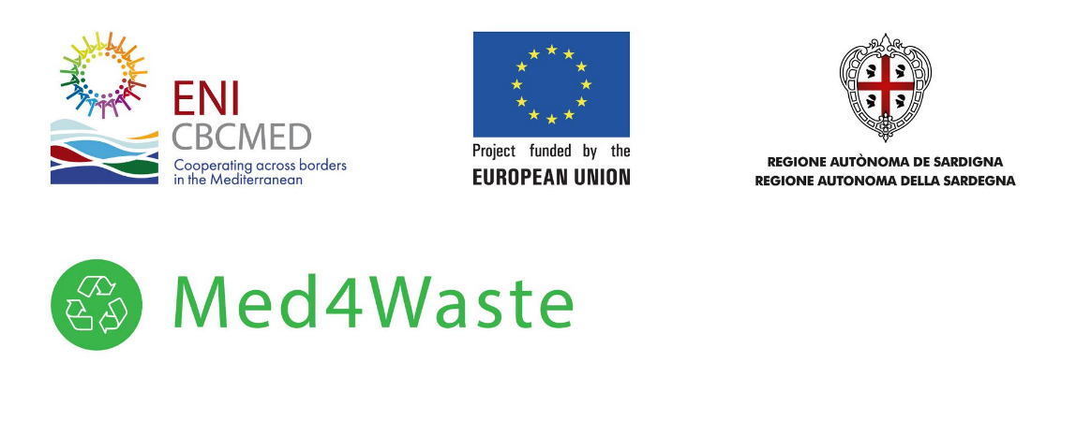

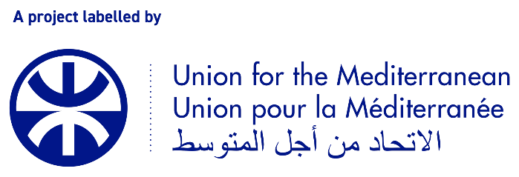

June 2023

1. The framework of the Med4Waste project
Med4Waste (Mediterranean Dialogue for Waste Management Governance) project is a 2-year-long capitalisation project funded by the ENI CBC MED programme on the priority of waste management. The Union for the Mediterranean (UfM) supports the development and implementation of this project within the 2030GreenerMed Agenda. The objective of the Med4Waste project is to facilitate new governance models for integrated and efficient urban waste management policies across the Mediterranean region, with particular emphasis on organic waste and circular economy through adapting waste management plans, policies and other management actions and regulatory drivers. Med4Waste focuses on the identification of successful and efficient waste management practices developed by 5 other ENI CBC MED projects, and their dissemination and mainstreaming into public polices and plans carried out by the relevant public or private stakeholders.
MIO-ECSDE is a key partner of this project bringing its expertise in the policy-society interface, stakeholder engagement, and capacity building for sustainable waste management. MIO-ECSDE is co-leading the policy dialogue, mainstreaming, and cross fertilization activities of the project and is the budget-holder for this specific activity.
MedCities is supervising the launching and managing the Med4Waste Mentoring Scheme, through which, Med4Waste will provide guidance and technical support to six sub-national authorities in charge of planning and managing waste in the Mediterranean in order to:
- improve or develop their integrated municipal waste management (IMWM) plan;
- exchange first-hand knowledge with a city that has implemented a method/tool/activity to enhance their waste management system (Twinning and Exchange program);
- implement a tailor-made supporting action aligned with their IMWM plan.

The following section describes the waste management context of Deir Qanoon El Naher Municipality and the proposed tailor-made supporting action as per the diagnosed needs of the municipality, one of the two Lebanese municipalities taking part in the Med4Waste Mentoring Scheme.

2. Background and Context
The municipality of Deir Qanoon ElNaher (DQN) is a village in the Tyre Caza in South Lebanon Governorate. Spreading over a surface of nearly 4 km², DQN is home to around 10,000 citizens. The municipal jurisdiction includes 400 stores, commercial and industrial institutions (non-residential) and 1050 residential units. The DQN municipality considers IWM one of its main priorities and as such, it has been working on it since 2019.

IWM is one of the main issues at the national level, with the central authorities’ inability to implement green and sustainable solutions, some local authorities have taken initiatives to find solutions for the waste generated within their respective jurisdictions. DQN has been a pioneer in this regard, they have drawn a city waste management plan (CWMP) in the year 2018 to find a solution for their waste as the nearby Ain Baal sorting facility stopped providing their service in 2017.

In 2019, the municipality embarked on a wide awareness raising campaign involving 120 young people and students to encourage local citizens to sort at source and dispose of the sorted waste in the designated bins. The trained youth went door-to-door to train hundreds of citizens on how to properly separate solid waste, among other activities.

Nowadays, the municipality of DQN receives around 9 tons/day of municipal waste on average (5-13 tons depending on seasonality). In 2019, the municipality raised the required funds to build and operate a Central Sorting Facility (CSF) to treat the generated waste of DQN, and entrusted its operation to an experienced contractor. The facility stretches over an area of 12 x 25 m² and can treat around 15 tons/day.

The waste is picked daily form the street bins which are dedicated to recyclables (red bins) and mixed waste (green bins). Upon collection, the waste is transferred to the CSF where the sorted recyclables are pressed, baled and are made available for trade while the mixed waste is being sorted separately and manually. It should be added that DQN is currently undertaking trials at composting sorted organic wastes, however, this initiative is still in its early stages.

The CSF is well equipped; however, the machinery is rarely used these days given the high cost of fuel that is required to operate and most of the work is done manually. However, it should be noted that the facility is cleaned on a daily basis and no repugnant odour can be detected as someone walks in.

Since late 2022, the municipality assumed the full management and operation of the entire waste management system. The municipality recovers part of the costs it incurs to run this solution through the sale of recyclable material at market rates. Given the amount of waste that has been produced during the first four months of the year 2023, in addition to the community’s low interest to commit to sorting at source, the DQN waste management system has led to a budget deficit.

The Municipality of DQN is considering scaling up their waste management service to neighbouring municipalities in order to sustain the system in the long-term. Given the prevailing conditions, the municipality does not have the capacity to treat all the collected waste from the neighbouring villages nonetheless it is exploring various options to address single-stream waste sources from these villages.

MedCities, through the mentoring scheme of the Med4Waste Project, supported the DQN municipality in diagnosing the current waste management system and the revision of the City Waste Management Plan. Nevertheless, the Municipality of DQN requires an expert analysis to understand what and how to scale up this service.

3. Implementation of a Tailor-Made Activity to support the Waste Management Plan of the Deir Qanoon El Naher Municipality (Lebanon)
The objectives of this project/tailor-made activity are the following:
Main Objective: Support DQN municipality in drafting an Action Plan to scale up their Waste Management Service to neighbouring villages.
- Secondary Objective 1: Support DQN Municipality in assessing the specific waste streams to be considered for the expansion of their waste management system;
- Secondary Objective 2: Draft an action plan that would chart the way forward for the municipality to sustain their waste management service.
- Secondary Objective 3: Build partnerships with two neighbouring municipalities to scale up the DQN Waste Management System.
To fulfil the aforementioned objectives, the below outputs will be produced:
- Output 1: A Cost-Benefit Analysis (focusing on the operational aspects) regarding the relevant and potential single-stream waste from neighbouring municipalities;
- Output 2: Based on Output 1, an Action Plan that will serve as a blueprint for DQN Municipality’s expansion;
- Output 3: Based on Output 2, signing two Memoranda of Understanding (MoUs) with the neighbouring municipalities in regards to the collection and treatment of the collected waste and the most convenient and efficient business model for their cooperation.
The aforementioned outputs will result from the below listed activities:
- Activity 1.1: Conduct an in depth-analysis of the waste management profile of DQN and the nearby municipalities (part of the 61 municipalities of the Union of Municipalities of Sour/Tyre).
- Activity 1.2: Draft a report specifying which waste-streams should be considered.
- Activity 2.1: Work closely with the Municipality of DQN and the allocated expert hired by MedCities to draft an Action Plan.
- Activity 2.2: Revise and amend the Action Plan based on the desired results pertaining Output 3.
- Activity 3.1: Engage the Municipality of DQN in a dialogue with other key stakeholders, namely the Union of Municipalities of Sour and the potential collaborating neighbouring municipalities.
- Activity 3.2: Support the Municipality of DQN in developing and signing two MoUs with the neighbouring municipalities.

The maximum available budget for this assignment is 5,000 EUR. This amount includes all other costs, income taxes and any other amount payable or cost that may be required for the completion of the work/service, including VAT.
The overall duration of this assignment will be a maximum of 3 months after contract signature.
Payments will be made upon acceptance and verification of the related deliverables, as laid out in the table below.
Tasks | Deliverables | Deadline | Payment Schedule
Conduct Cost-Benefit Analysis | Output 1 | 1 month after contract signature | Tranche 1: 30%
Finalize Action Plan and signing of the MoUs | Outputs 2 and 3 | 3 months after contract signature | Tranche 2: 70%

4. Time Frame
The realization of the activity and the above-mentioned deliverables have to be successfully completed by the 4th of September 2023.
Provisional implementation timetable:
Activities | Weeks
 | 3-Jul-23 | 10-Jul-23 | 17-Jul-23 | 24-Jul-23 | 31-Jul-23 | 7-Aug-23 | 14-Aug-23 | 21-Aug-23 | 28-Aug-23 | 4-Sep-23
Activity 1.1: In depth analysis of the waste management profile of DQN and its neighbouring villages; (incl. a cost-benefit analysis focusing on operational aspects);
Activity 1.2: Draft a report specifying which waste-streams are feasible for consideration;
Activity 2.1: Drafting an Action Plan;
Activity 2.2: Revise and amend the Action Plan based on the results pertaining Output 3;
Activity 3.1: Engage with key stakeholders (UoM Municipalities)
Activity 3.2: Sign two MoUs with the neighbouring municipalities

5. Qualification Criteria (ON/OFF)
Successful participant (Natural or Legal Person or Entity):
- Must have a record of minimum 1 successfully implemented similar projects in terms of waste management and public administration in the last 5 years and ongoing.
- Must be enrolled in one of the official professional or trade registries kept in their country of registration.
The proposed Expert or Team Leader (in case of a group of experts) must have:
- Post graduate diploma (at least MSc or equivalent) in a field relevant to the Assignment (e.g. Waste management, Public Administrations, Environmental Policy/Management, Environmental engineering etc)
Successful participant (Natural or Legal Person or Entity) must also have:
- 5-10 years of experience working in the Local Authorities Development Sector;
- A strong knowledge of Waste Management Governance Frameworks in Lebanon (min. 2 years of professional experience);
- Good understanding of the local context and culture (living in the proximity of the described area);
- A proven track record in building partnerships among municipalities and local authorities;

Failure to provide the minimum criteria is considered ground for disqualification.

7. Awarding Criterion

The Most Economically Advantageous offer with criterion the lowest price for the offers satisfying the qualification criteria.

ANNEX II: SUBMISSION LETTER

To be put in Suppliers Letterhead paper

[insert: Location], [insert: Date]

To: MIO-ECSDE, 12 Kyristou str. 105 56 Athens, Greece

Dear Sir/Madam:

We, the undersigned, hereby offer to provide professional services for the implementation of a Tailor-Made Activity to support the Waste Management Plan of the Deir Qanoon El Naher Municipality (Lebanon) in accordance with your Request for Offers dated 28/6/2023. We are hereby submitting our Offer as requested and

We hereby confirm that:
- All the information included in our offer are true;
- We are currently not on the removed or suspended vendor list of the UN or other such lists of the EU, nor are we associated with, any company or individual appearing on the 1267/1989 list of the UN Security Council;
- We have no outstanding bankruptcy or pending litigation or any legal action that could impair our operation as a going concern;
- We have no pending obligations relating to the payment of social security contributions and the payment of taxes in accordance with the legal provisions of the country in which we are established and
- We do not employ, nor anticipate employing, any person who is or was recently employed by MIO-ECSDE.

We confirm that we have read, understood and hereby accept the Terms of Reference describing the duties and responsibilities required of us in this Request for Offers.

We confirm that our offer is bidding for a period of one month.

We confirm that if our offer is accepted, will provide the services in accordance with the terms of the Request for Offers documents and the conditions and time limits laid down, without reservation or restriction and in the requested timeframe.

Yours sincerely,

Authorized Signature [In full and initials]:
Name and Title of Signatory:
Name of Firm:
Contact Details:

ANNEX ΙII: FINANCIAL OFFER

Ref: 3/2023/MED4Waste

Supplier’s Details:

Company Name:
Address:
Tel/ e-mail address:
VAT or Registration No: (If Applicable)
Establishment date: (If Applicable)
Name of Legal Representative: (If Applicable)

Offer:

Prices are to be quoted in EURO Including VAT and any other Tax or Fee that should apply for any reason.

Item | Description | Total in EURO including VAT
1 | Implementation of a Tailor-Made Activity to support the Waste Management Plan of the Deir Qanoon El Naher Municipality (Lebanon) – Outputs 1, 2 and 3
 | Grant Total in Euro

_____________________________ _____________________________
Signature Date

