CALL FOR APPLICATIONS
(extension of 2nd Round)
for organizing a
MIO-ECSDE “Mediterranean Action Day 2021” activity on:

Ocean Literacy for All Mediterranean People:
The Ocean We Need for the Future We Want

In the framework of:
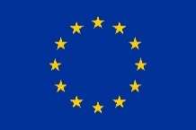
The Annual Programme of MIO-ECSDE
supported by the EU LIFE Programme | Operating Grant for NGOs.

Version: 22 July 2021

The Call

Context: the Mediterranean Action Day is an annual activity of MIO-ECSDE that gives the opportunity to MIO-ECSDE member organizations and other NGOs to take action in the field and be more visible to their target populations while at the same time tackle a frontline environmental issue of their municipality, region or country.

In the context of the MIO-ECSDE Annual Programme (supported by the EU LIFE Programme - Operating Grant for NGOs), MIO-ECSDE is requesting expressions of interest (or applications) of its member organizations and other NGOs, based in the following EU countries: Cyprus, Croatia, France, Greece, Italy, Malta, Portugal, Slovenia, and Spain, for the realization of up to 8 ocean literacy activities. Each activity will be performed by different NGOs in the above-mentioned countries, that will be chosen through the present selection procedure. Grassroot organizations will be given preference and the intention is to give access to as many countries as possible.
Each participating NGO will have the initiative and responsibility for the set-up of their activity.
MIO-ECSDE requests NGOs interested in organizing an ocean literacy related activity to submit their application electronically to info@mio-ecsde.org (topic title MAD2021). They shall use the template provided in Annex 1 (Application Form) to describe the activity that they propose.
SUBMISSION OF APPLICATIONS BY: 26 July 2021 2 August 2021
Applications submitted after the specified date shall not be considered. The successful candidates will be notified within 15 working days after the submission deadline.

BUDGET CEILING: the total budget for this call is €16.000 to be divided in 8 parts of €2.000 per activity and organization. The amount shall include all other costs, income taxes, and any other amount payable or cost that may be required for the completion of the activity.
ASSESSMENT CRITERION: the relevance and quality of each application and proposed activities based on the requirements presented in detail in this call and the attached ToR as well as Expertise and Experience (years) of the expert(s) in charge.
THE CALL WILL PROCEED HAVING REGARD TO:
- The Internal Rules and Regulations of MIO-ECSDE.
- The present Call for Applications.
QUALIFICATION CRITERIA (PASS/FAIL): Failure to provide/prove the following is considered grounds for disqualification.
- The successful candidate must be a registered NGO that possesses adequate capacity.
- If the applicant is a MIO-ECSDE member organization, proof of payment of the 2019 and 2020 Membership fees must be submitted.
For any clarification on the present call please address:
Name: Haris Paliogiannis | Tel: +30-210-3247267, -2103247490 | e-mail: info@mio-ecsde.org or paliogiannis@mio-ecsde.org
The present call is posted on the MIO-ECSDE website www.mio-ecsde.org.
Background on Ocean Literacy
Most of us live our lives unaware of how our day-to-day actions affect the health and sustainability of the ocean and its many resources on which we depend. Nor do most of us recognise how the health of the ocean affects our daily lives. This is what Ocean Literacy is about: a deepened understanding of the ocean’s influence on us and our influence on the ocean. There are 7 principles of ocean literacy as shown in the figure below.
Reversing the cycle of decline in ocean health and sustainably using the marine resources for sustainable development will require a paradigm shift in our lifestyles and a transformation of the way we think and act. To achieve this change, we need new skills, values, and attitudes that lead to more ocean sustainable societies. In this respect, just educating or informing all societal actors about the importance of the ocean is not enough. We need to go beyond ocean science communication and engage the society at large in cascading, comprehensive and continuous actions pinpointed by informed and responsible decisions on ocean resources and ocean sustainability; while also learning from and building upon local and indigenous knowledge.
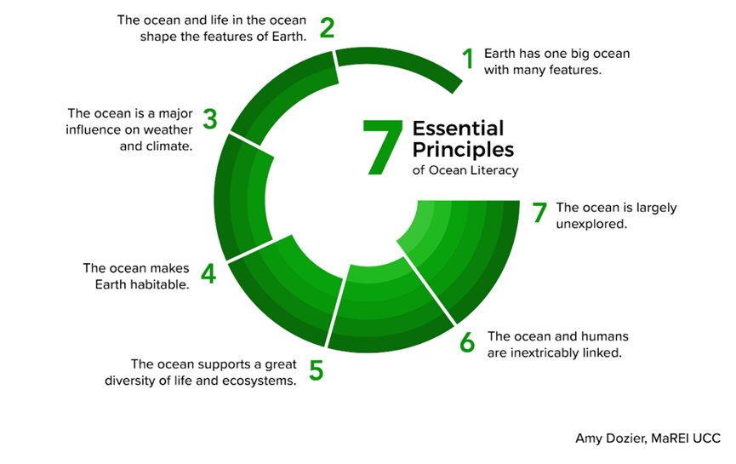
Figure 0. The 7 principles of ocean literacy and ocean science communication.

The year 2021 marks the launch of the United Nations Decade of Ocean Science for Sustainable Development (2021-2030) aiming to advance ocean science and sustainable use of the ocean and reverse the cycle of decline in ocean health. The ambition of the Decade of Ocean Science is to mobilize the scientific community, policy-makers, and society at large around a program of joint research and technological innovation to get the ocean back on track. The launch of the Decade has already provided a glimmer of hope and societal actors are already gearing up to make best use of a once-in-a-lifetime opportunity to draw attention to the world’s oceans, make a lasting impact on enhancing scientific knowledge, and create improved conditions for sustainable development of the oceans.
The achievement of the Decade’s objectives relies largely on the new ocean narrative that should be developed and provide context and motivation to reduce ocean pressures, increase ocean resilience, and promote ocean prosperity for generations to come. In this sense ocean science communication and ocean literacy are key in influencing behaviours and perceptions of scientists, decision-makers and societal actors
By supporting national and local NGOs to carry out ocean literary related activities, MAD 2021 aims to reach out to Mediterranean citizens and individuals, inviting them to take effective ocean actions in direct and “creative” ways, to address ocean-related challenges such as:
- Marine pollution, including noise or biological pollution from invasive alien species
- Overexploitation of marine resources
- Climate change
- Seafloor physical loss/damage and habitat destruction

Terms of Reference

Timeline
Applications should be submitted by 26 July 2021 02 August 2021.
Approved actions are expected to take place between August and October 2021.

Types of activities
Applicants should design and implement an activity to enhance ocean literacy in the Mediterranean and facilitate the creation of ocean-literate societies.
Below is an indicative list of activities that the NGOs applying for support under this call should use for inspiration:
- Setup an ocean literacy campaign/exhibition to promote actions towards the achievement of SDG14 “Conserve and sustainably use the oceans, seas and marine resources” by addressing one of the ocean related challenges mentioned in the background section.
- Implement social media campaigns and online contests (video, photo, art, etc.) as present-day, attractive, interactive and effective tools for ocean science communication and ocean literacy.
- Organize an event to promote the value of Mediterranean Marine Natura 2000 sites and other Marine Protected Areas towards attaining favorable conservation status for Mediterranean habitats and species.
- Organise local, national or regional workshops/webinars/conferences to provide content and activities for the support of marine education in formal and non-formal education settings;
- Organise local, national or regional workshops/webinars/conferences targeted to different stakeholders and focused on one or more ocean-related challenges with the aim to enhance skills, create values, and change attitudes ultimately leading to more ocean sustainable societies.
- Setup a campaign to promote a participatory science activity focused on the marine environment. Below are some indicative tools that can be used:
- Marine LitterWatch App is an app developed by the European Environment Agency where citizens can monitor marine litter on beaches following the guidelines of the Marine Strategy Framework Directive.
- MedMIS App is an online information system to track invasive species in the Mediterranean Marine Protected Areas consisting of a mobile app and web platform that has been developed for IUCN.
- EyeOnWater App is an app that helps classify coastal waters, seas and oceans based on their colour.
- Setup and carry out a survey to assess the views and perceptions of stakeholders on an ocean literacy related issue. An indicative example: the survey for the evaluation of stakeholder perceptions and attitudes towards issues surrounding marine litter performed with the FP7 MARLISCO project (http://www.marlisco.eu/stakeholder-survey.en.html).
You can find some ocean literacy-dedicated resources in the links below:
- The Horizon 2020 ResponSEAble project https://www.responseable.eu
- The Horizon 2020 SeaChange project, https://www.seachangeproject.eu
- The UNESCO Ocean Literacy Platform, https://oceanliteracy.unesco.org

See Annex 2 for guidance on the organization of sustainable events.

Target groups
The involvement of as many people and sectors as possible in your ocean literacy action is a must. Therefore, the more and diverse the participants, the better. Gender and youth mainstreaming considerations are key. Also, the presence and or involvement of the media is strongly encouraged, as it will help the purpose of the action itself and the dissemination of messages.
The action can be targeted to:
- educators (formal and non-formal);
- students from schools, colleges, universities;
- the general public/citizens;
- other NGOs (focusing on the ocean, youth, sustainable management, etc.);
- civil servants at all levels;
- the private sector (e.g. SMEs);
- professionals such as divers, local cooperatives, fishermen, etc.;
- women’s associations;
- research institutes;
- government officials;
- the Media;
- etc.

Application Submission
Participation in this Call for Applications is open, on equal terms, to all NGOs who meet the conditions laid down in this Call where they possess adequate capacity.
Interested Parties should submit to info@mio-ecsde.org by 26 July 2021 02 August 2021:
- a completed and signed application form (see Annex 1);
- Certificate of official registration of the NGO
- VAT number registration
- Certification of the legal representative/signatory of the NGO
- CV(s) of the team member(s) / expert(s);

Qualification, Requirements and Evaluation Criteria
- Failure to provide/prove the following is considered grounds for disqualification.
- The successful candidate must be a registered NGO that possesses adequate capacity.
- If the applicant is a MIO-ECSDE member organization, proof of payment of the 2019 and 2020 Membership fees must be submitted.
- The eligible applications will be evaluated based on the following:
- Relevance of the proposed activity based on the Application Form
- Expertise and Experience (years) of the expert(s) in charge: The scope of work requires at least one skilled professional with previous experience in ocean and/or climate literacy, maritime issues, marine sciences and conservation, etc. and with proven interest and expertise on the issue.
Applications submitted after the specified date shall not be considered. The successful candidates will be notified within 15 working days after the submission deadline.

Financial Support
An amount of €2.000 is available per successful applicant as seed funding to support the related action.
Eligible costs include:
- labour cost
- local travel cost
- meeting costs such us lunch/coffee and/or technical support
- costs for media campaigns, filming and/or broadcasting of the OL activity in order to enhance impact
- costs for purchasing relevant eco-promotional products with a message such as a thermos to advocate against single use plastic bottles, bags made of organic cotton to replace single use plastic bags, binoculars for bird watching, etc.
The amount includes all other costs, income taxes, and any other amount payable or cost that may be required for the completion of the work/service.
Financial monitoring and reporting will be carried according MIO-ECDSE’s financial rules and procedures (and those that apply for the EU LIFE Programme).

Indicative timeline of actions and deliverables
The successful applicants should follow the timeframe below:
Actions | Timeframe
1. Call for interest announced by MIO-ECSDE | 10 June 2021 (1st round)  7 July 2021 (2nd round)
2. Reception of the application forms from the interested NGOs | 26 July 2021  02 August 2021
3. Review of the application forms and selection of NGOs completed | by 16 August 2021
4. Signing of agreements | by end of August 2021
5. Activity implementation | by end of October 2021
6. Activity report (using the template provided by MIO-ECSDE) | by end of November 2021

The present call for applications is posted on the website of MIO-ECSDE (www.mio-ecsde.org).

Checklist
Make sure that your submission is complete! | CHECK
A completed and signed application form (Annex 1) is attached
Official registration certificate is attached
VAT number registration is attached
Certification of the legal representative/signatory of the NGO is attached
CV(s) of the team member(s) / expert(s) are attached
Proof of payment of the 2019 and 2020 Membership fees (only if the applicant is a MIO-ECSDE member organization)
ANNEX 1: APPLICATION FORM

MIO-ECSDE MEDITERRANEAN ACTION DAY 2021

Name of NGO:
Country:
Our NGO would like to participate in the proposed activity:
Name of person in charge:
Function in the NGO:
Address:
Tel:
e-mail:
website:
Title of proposed activity:
Description of proposed activity (max. 500 words): Make sure to include:
- Objective of the proposed activity
- Target group
- Expected results
- How you plan to achieve your expected results (actions/activities including communication, promotion and gender/youth mainstreaming)

Estimated Budget Analysis for the Proposed Activity:
Expenses Category | Expense Description | Total amount (Euros)
Labor costs (staff or external expertise)
Travel/transportation costs
Promotional materials
Media costs (filming-broadcasting, social media campaign)
Catering of event
Technical support
Please add /delete categories as relevant
……..
……..
TOTAL max (2.000 euros)

Period/date foreseen for the MAD 2021 activity to be held:

Having read and understood the Terms of Reference, I undertake the responsibility of organizing the activity.

Signature: __________________________ Date: _______________________

ANNEX 2: SUSTAINABLE EVENTS
A sustainable event is one that is designed, organized, and implemented with a view to minimizing its ecological footprint and maximizing its positive impact on society. To reduce the general impacts of our events and their ecological footprint, we should therefore always consider the life cycle when we organize an event, in order to identify the points that will have a bigger negative impact on the environment.
Below are listed some useful tips that should be used wherever applicable in order to minimize the ecological footprint of our event to the extent possible.

Sustainability target | How
Reduce energy use and the resulting greenhouse gas emissions | - Select venues and accommodation that implement energy efficiency measures, comply with green building standards, and/or use renewable energy sources.  - Choose locations and venues minimizing local and long-distance transportation needs for participants and products.  - Where long-distance travel is unavoidable, offset GHG emissions.  - Apply energy-saving office practices during the organization and hosting of the event.
Reduce materials consumption and waste generation | - Minimize materials provided to participants and used by service providers (e.g. caterer, exhibitors) before, during, and after the event.  - Avoid the use of disposable items, use pre-used/ recycled and reusable/recyclable products, and reduce packaging needs to a minimum.  - Separate and recycle waste where possible.
Reduce water use | - Select venues and accommodation that implement water conservation practices and use water-efficient appliances.  - Implement water-conscious measures such as avoid bottled water and re-filling glasses only upon request.
Reduce indirect environmental impacts on air, water and soil | - Minimize the need to transport food and other products and favor local organic food.  - Use products manufactured with or containing fewer harmful substances, such as chlorine-free paper and non-toxic cleaning products.
Increase the social benefits for all involved | - Involve local and regional economies as much as possible by, for example, recruiting local people (social integration), supporting SMEs (catering, energy, cleaning, IT supply, family-run accommodation), and showcasing successful local projects.  - Contribute to the Sustainable Development Goals and the core ILO Conventions through compliance with labour standards, and requiring social integration (reducing unemployment), Fair Trade products, and social criteria along the supply chain.  - Assure security and health aspects (e.g. noise level).

