Application Form

ACT4LITTER MARINE LITTER WATCH MONTH
IN MED MPAs

First name
Surname
Title
Organization
Contact e-mail
MPA name where the beach litter survey(s) will take place
Country
Number of sites to be surveyed
Interested in joining the webinar of the 12th of December 2017 (YES/NO)
Interested in joining the webinar of the 15th of December 2017 (YES/NO)

Please send the form to the following e-mail address: vlachogianni@mio-ecsde.org

by the 8th of December 2017

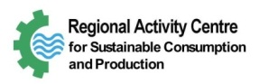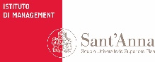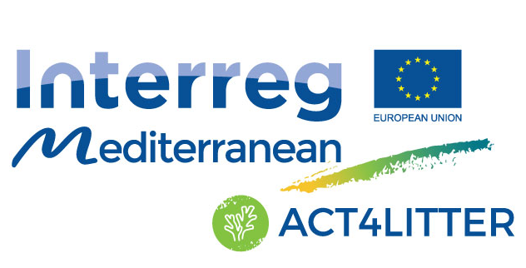  Catalan Waste Agency - Regional Activity Center for Sustainable Consumption and Production  MedPAN – Network of Marine Protected Area Managers in the Mediterranean  Mediterranean Information Office for Environment, Culture and Sustainable Development  Sant’Anna School of Advanced Studies | Joint measures to preserve natural ecosystems from marine litter in Mediterranean Marine Protected Areas

