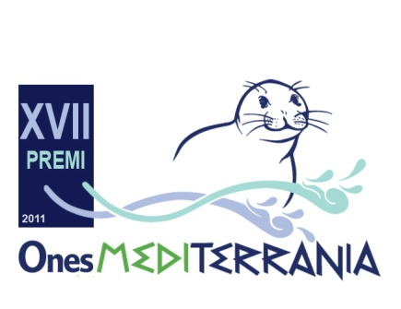
Mediterrània CIE and MIO-ECSDE are calling for candidates to be considered for the 11th MEDITERRANEAN HONORIFIC AWARD, addressed to innovative projects relating to the environment and sustainable development.

11th MEDITERRANEAN HONORIFIC AWARD

DESCRIPTION: This award is open to all those organisations in the Mediterranean region working for the protection of the environment and cultural heritage, as well as on sustainable development issues. This year any ongoing action combining art/culture and environmental/sustainable development can apply.

This award will only apply for the diffusion of the project and its results, understanding that the projects themselves are already financed by other sources.

REQUIRED DOCUMENTS:
- A presentation letter clearly stating the complete name of the project, as well as the objectives of the project and how the project manager got to know about this award.
- Brief summary of the project. This summary must be up to 20-40 lines long, containing in a concise way the most relevant aspects of the project.
- A detailed description of the project (maximum 10 pages). A hard copy (paper) and a digital copy (by e-mail) must be presented. It has to include: objectives of the project, justification, methodology followed, budget, resources and control and follow-up mechanisms, following the form which must be downloaded from www.mediterrania-cie.org.
- A file with information on the organization or person conducting the project.

LANGUAGE: English

ENTRY DATES: from March 10th until May 10th

PRIZE: MIO-ECSDE will offer the winner a symbolic amount so as to support the diffusion of the project’s outcomes.

JURY:
- Prof. Mohammed Ftouhi, MIO-ECSDE Co-Chairman.
- Ms. Patrizia Bonelli, MIO-ECSDE executive Bureau
- Vicky Malotidi, Mediterranean Education Initiative on Environment and Sustainability (MEdIES).
- Ángel Juárez, President of MARE TERRA Foundation.
- Raquel Quílez, Technical Assistant (Mediterrània-CIE).

Attention: Presenting a project assumes full acceptance of the competition’s terms and rules, as well as the authorization for the reproduction and diffusion of the result by Mediterrània-CIE. If none of the submitted projects fulfil the award’s specifications or expectations, then none will be awarded. Any doubts concerning the competition will be solved by the jury members. The original submission will be returned to the applicant who requests it in three months time from the awards ceremony.

DELIVERY TO: the projects must be submitted by post and by e-mail to:

MEDITERRÀNIA, CENTRE D’INICIATIVES ECOLÒGIQUES

C/Francolí, 56-58 Tarragona 43006. Spain
Tel: (+34) 977 55 13 00
Fax: (+34) 977 55 09 28

E-mail: direccion@mediterrania-cie.org; ursula.juarez@mediterrania-cie.org

Web: http://www.mediterrania-cie.org

