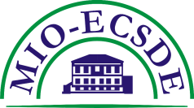 | MEDITERRANEAN INFORMATION OFFICE  FOR ENVIRONMENT, CULTURE AND SUSTAINABLE DEVELOPMENT  (MIO-ECSDE)

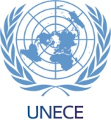
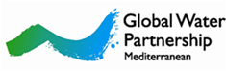
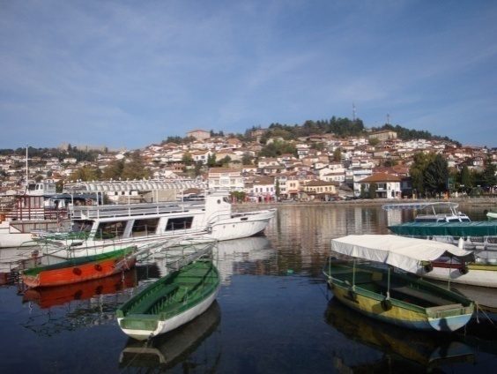
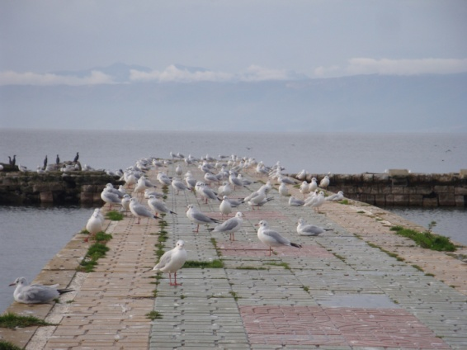
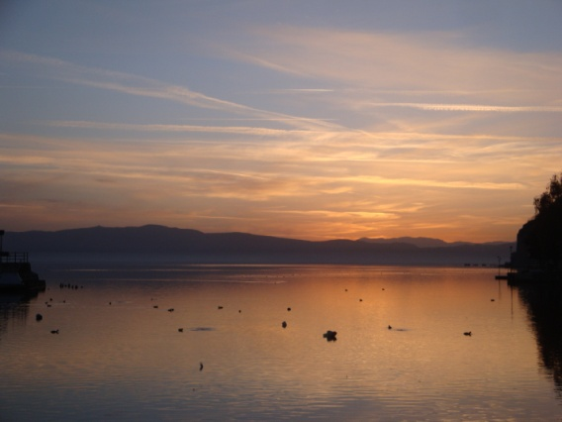
12 November 2010
prepared by Thomais Vlachogianni
REGIONAL WORKSHOP
“Sustainable management of river and lake basins:
Empowering NGOs for a coordinated effective involvement”
4 November 2010, Ohrid, FYROM
Draft Report

“Sustainable management of river and lake basins:

Empowering NGOs for a coordinated effective involvement”

4 November 2010, Ohrid, FYROM
Report of the workshop

Introduction
Given the wide range in competences, areas of interest and character of NGOs within the wider civil society sector their important role in promoting sustainable water resources management has been widely recognised. This includes the active participation of NGOs at local, national and transboundary level in all phases of watershed management planning and implementation (design, implementation in the field, operationalization, monitoring and evaluation). In order to ensure a meaningful, coordinated and effective participation of NGOs in the above mentioned cycle, there is a need to enhance their abilities and capacities to act throughout these processes in transboundary initiatives.
The regional workshop on “Sustainable management of river and lake basins: Empowering NGOs for a coordinated effective involvement” took place in Ohrid, FYR Macedonia on the 4th of November 2010 and was organized by the Mediterranean Information Office for Environment, Culture and Sustainable Development (MIO-ECSDE) in cooperation with the United Nations Economic Commission for Europe (UNECE) and the Global Water Partnership – Mediterranean (GWP-Med). This workshop was the first of a series of events (meetings/consultations/workshops) to be organized in 2010-2011 focusing on the key role that civil society can play in transboundary dialogue processes such as the Drin Dialogue.

The Framework
The Drin Dialogue was launched on December 1st, 2009 and aims to establish a Shared Vision for the management of the extended Drin River Basin. The meeting established a coordinating body, the Drin Core Group and MIO-ECSDE as the major NGO Federation, was included as member of this group. The Drin Core Group is composed of representatives of the ministries responsible for water management in the riparian countries, as well as formal and informal joint structures established in the shared river basin (the Prespa, Ohrid and Shkoder Lakes), such as UNECE and GWP-Med.MIO-ECSDE as a member of the Drin Core Group committed itself to support the dialogue at regional level, to contribute in establishing a common understanding and shared vision and in enhancing the ability and capacity of its NGO members and other collaborating NGOs in order to act in an effective and constructive way.
To enhance synergies and impact, the workshop was organized within the framework of two other major Mediterranean initiatives, in which MIO-ECSDE is a key partner:
- The UNEP/MAP - GEF Strategic Partnership for the Mediterranean Large Marine Ecosystem (the MedPartnership), where MIO-ECSDE is responsible for the meaningful participation of civil society in the implementation of the project and the overall strengthening of civil society in the region.
- The ENPI Horizon 2020 Capacity Building/Mediterranean Environment Programme (CB/MEP) which focuses on environmental integration and capacity building and aims through targeted activities within the partner countries to increase the capacities of all stakeholders (administrations – national, sub national, local authorities – NGOs, private sector, etc.) so as to effectively contribute to the de-pollution of the Mediterranean Sea by 2020.

Aim and objectives
The main objectives of the workshop were:
- to provide the opportunity to NGOs to exchange experiences about their involvement in the development of river or lake basin management plans;
- to identify obstacles and challenges to successful participation of NGOs and strengthen the relations between the various organisations of the region;
- to give participants the opportunity to exchange experiences about the operationalization of different participatory frameworks e.g. the Aarhus Convention, the acquis communautaire, the EU directive for Public Participation, etc.;
- to identify/brainstorm/exchange views and ideas on appropriate pilot actions to be considered in the framework of a GEF supported project under formulation, on transboundary cooperation and integrated water resources management.

Participants, Methodology and Structure
Fourteen representatives of national and local NGOs from Albania, FYR Macedonia and Montenegro participated in the one-day workshop. The workshop followed a participatory and interactive approach allowing the familiarization of the participants with the relevant conceptual public participation approaches and tools while providing at the same time case-specific examples from within and outside the South Eastern Europe (SEE) region.
The agenda of the workshop included a lecture, presentation of case studies, plenary discussions and a brainstorming exercise. The approach followed enhanced sharing of experiences among participants.

Presentations & Discussions
In the morning session, Mr. Bo Libert (UNECE) [the relevant presentation can be found here] and Prof. Michael Scoullos (MIO-ECSDE, GWP-Med) [the relevant presentation can be found here] provided to participants information on the general framework for effective NGO/ stakeholder involvement in the development of sustainable river and lake basin management plans, at international and European level. The different participatory legal frameworks were outlined and experiences on their operationalization in EU and Southeast European processes and mechanisms (such as the Water Framework Directive, Integrated Water Resources Management, Integrated Coastal Zone Management, Environmental Impact Assessments, Strategic Environmental Assessments, etc.) were exchanged. Emphasis was given to public participation in transboundary water cooperation through the presentation of international examples such as the Baltic Sea Basin, including the transboundary Lake Peipsi/Chudskoe Basin shared by Estonia and Russia, etc. Later on, Mr. Dimitris Faloutsos (GWP-Med) presented the Drin Dialogue process and its underlying mechanisms towards the development of a Shared Vision for the management of the “extended” Drin River Basin [the relevant presentation can be found here]. A discussion followed on the major outcomes of the National Consultation that took place on the 2nd of November 2010 in Ohrid. This session was closed with Mr. Milan Vogrin (DPPVN, DEF) [the relevant presentation can be found here] and his case study presentation on experiences of NGO Participation in the Danube River Basin Management Plans.
In the afternoon session, after a brief presentation of all NGOs present and their corresponding activities, the discussions focused on the identification of the main challenges, obstacles for effective NGO involvement in the development of river and lake basin management plans in the Balkans; the measures to overcome these obstacles and address the future challenges; and the roles that the national NGO community can play in the Drin Dialogue. An important part of the discussions was devoted to approaches for a better coordination/cooperation of NGOs and their effective involvement in the Drin Dialogue and ideas/suggestions on appropriate pilot actions that NGOs could undertake or would like to see in the framework of the Drin Dialogue.

Conclusions & Recommendations
Herewith are summarized the main issues discussed during the second half of the workshop:
- Main challenges, obstacles for effective NGO involvement in the development of river and lake basin management plans in the Balkans.
- Lack of capacity and expertise on NGOs at local/national level and lack of human resources;
- Lack of funds and/or knowledge on how to access funds;
- Lack of coordination between national/local NGOs;
- Weak cooperation/collaboration among NGOs at national or local level;
- Severe constraints on the capacities and culture of local/national administration bodies;
- Appropriate administrative bodies are not in place to take NGO views on board;
- Lack of local donors;
- Lack of continuation/sustainability of activities that have been initiated within the framework of a project;
- Frequent cases of opportunistic NGOs, that adapt their scope according to funding prospects that arise;
- No access to information or limited access to unreliable data regarding environmental issues;
- Cultural/educational issues.

- Measures to overcome the obstacles relating to NGOs and address future challenges.
- Gain expertise/knowledge through participation in relevant trainings, workshops, etc.
- Enhance cooperation/coordination among NGOs at local/national level;
- Enhance networking and joint cross boarder activities between NGOs (e.g. through submission of joint proposals for funding in cross boarder projects;
- Create a forum to bridge gaps between NGOs and governments.
- Approaches for a better coordination/cooperation of NGOs and their effective involvement in the Drin Dialogue.
- Participate in capacity building activities e.g. in the Framework of Horizon H2020 Capacity Building/Mediterranean Environment Programme or in the activities undertaken within the annual programme of MIO-ECSDE to support and contribute to the objectives of the Drin Dialogue;
- Raise awareness through various activities at local and national level on the Drin Dialogue process, promote the importance of NGO and stakeholder involvement in the Drin Dialogue, participate or encourage the participation of NGOs and other stakeholders in the national consultations;
- Benefit from MIO-ECSDE’s experiences/expertise on participatory processes and give MIO-ECSDE the role to coordinate NGOs at local/national level (potentially through the nomination of national NGO Focal Points) in order to ensure the effective and fruitful participation of NGOs in the Drin Dialogue.

- Ideas/suggestions on appropriate pilot actions that NGOs could undertake or would like to see in the framework of the Drin Dialogue.
- The development of a toolkit on Public Participation (specific focus should be given on practical aspects);
- Capacity building activities on engaging civil society actors in regional and national processes of relevance, such as the Drin Dialogue;
- Implementation of appropriate awareness raising activities (dissemination of information materials, study visits, etc.) targeted to different stakeholders of the Drin Dialogue;
- Develop specific guidelines for the effective involvement of civil society in the Drin Dialogue;
- In parallel with the Drin Dialogue explore funding possibilities to develop a cross-border cooperation framework (with less political complexity) that could serve as a best practice example highlighting how crucial the involvement of NGOs is in achieving a successful outcome and demonstrating ways to effectively engage civil society actors in projects, processes, etc.

ANNEX I: Agenda of the workshop

9.00-9.10 | Opening remarks | Prof. M. Scoullos  Chairman of MIO-ECSDE
9.10-9.40 | Experiences with NGO/stakeholder involvement in river basin management plans | Mr. Bo Libert  Regional Adviser on Environment Environment, Housing and Land Management Division, UNECE
9.40-10.00 | Self-presentation of participants and topics of interest | Moderator: Prof. M. Scoullos
10.00-11.00 | The general framework for effective NGO/stakeholder Involvement in the development of sustainable river or lake basin management plans | Prof. M. Scoullos  Chairman of MIO-ECSDE
11.00-11.30 | Coffee Break
11.30-12.00 | The Drin Dialogue: Developing a Shared Vision for the management of the “extended” Drin River Basin | Mr. D. Faloutsos  GWP-Med Programme Officer
12.00-12.30 | NGO Participation in Danube River Basin Management Plans: the experience of Danube Environmental Forum (DEF) | Mr. Milan Vogrin  DPPVN, Board Member of DEF
12.30-14.00 | Lunch Break
14.00-15.30 | Exercise/Discussion: Obstacles and challenges regarding NGO participation in river and lake basin regions and ways to overcome/address them | Participants
15.30-16.30 | Exercise/Discussion: Approaches for a better coordination/ cooperation of NGOs and their effective involvement in the Drin Dialogue | Participants

ANNEX II: List of Participants

Name | Surname | NGO/Organization | Country | Email
Neshad | AZEMOVSKI | BIOSFERA-BITOLA | FYROM | biosfera@t-home.mk
Julia | CANGA | ECAT TIRANA | ALBANIA | ecat@ecat-tirana.org
Dimitris | FALOUTSOS | GWP-MED | GREECE | dimitris@gwpmed.org
Xhavit | GHASI | NGO “HERITAGE” –SKOPJE MKD | FYROM | archgashi@hotmail.com
Dusko | HRISTOV | 4X4X4 BALKAN BRIDGES SKOPJE | FYROM | 4x4x4bb@gmail.com
Bo | LIMBERT | UNECE |  | Bo.Libert@unece.org
Marisa | LOZAREVSKA | BIOSFERA-BITOLA | FYROM | marija26041986@yahoo.com
Jelena | MAROJEVIC | GREEN HOME PODGORICA | MONTENEGRO | greenhome@t-com.me, jelena.green@t-com.me
Boris | MATESKI | SCAUT CLUB OHRID/GREEN CENTER | FYROM | b.mateski@yahoo.com
Vilma | PULLEJA | INCA | ALBANIA | vipulleja@yahoo.com
Kiril | RISTOVSKI | FLOROZON – NGO | FYROM | florozon@hotmail.com, kiril.ristovski@florozon.org.mk
Michael | SCOULLOS | MIO-ECSDE | GREECE | scoullos@mio-ecsde.org
Valbona | SIMIXHIU | ECAT TIRANA | ALBANIA | ecat@ecat-tirana.org
Florentina | STERJOVSKA | GREEN CENTER | FYROM | fsterjovska@yahoo.com
Boris | STOJAMOSKI | EK. ASSOC. GRASNICA | FYROM | grasnica@yahoo.com
Emilija | STOJANOVSKA | BIOSFERA-BITOLA | FYROM | emastojanovska@gmail.com
Denik | ULQINI | RAINBOW ENVIRONMENTAL ASSOCIATION | ALBANIA | denik_ul@yahoo.co.uk
Thomais | VLACHOGIANNI | MIO-ECSDE | GREECE | vlachogianni@mio-ecsde.org
Milan | VOGRIN | DPPVN | SLOVENIA | milan.vogrin@guest.arnes.si

The Mediterranean Information Office for Environment, Culture and Sustainable Development (MIO-ECSDE) is the major Federation of environmental NGOs from the entire Mediterranean region. It was established in 1991. Today its membership numbers 112 NGOs from 26 countries. Its Secretariat is based in Athens, Greece. MIO-ECSDE acts as a powerful political and technical platform for the presentation of views and intervention of NGOs in the Mediterranean scene. In co-operation with international organisations, governments and various socio-economic partners, MIO-ECSDE plays an active role for the protection of the environment – including the aquatic one and water resources- and the promotion of the sustainable development of the Mediterranean region. It is one of the founding members of GWP-Med.

